Gregory D. Scott
Vice President, Human Resources and Communication
SSAB Americas

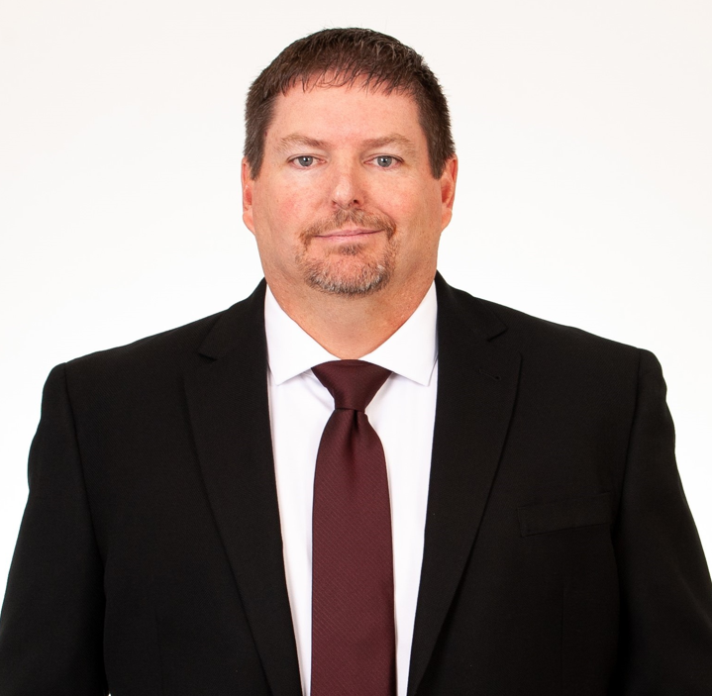

Greg Scott is vice president, human resources and communication, for SSAB Americas, a leading steel plate producer in North America. SSAB operates two steel mills located in Montpelier, IA and Mobile, AL, together with three cut-to-length processing facilities located in Houston, TX; St. Paul, MN; and Toronto, ON.

Greg has approximately 28 years’ experience in manufacturing and distribution. He began his career in the paper industry and has worked in automotive, medical device manufacturing, medical and pharmaceutical distribution industries prior to entering the steel industry with SSAB. He joined SSAB in 2014 and was promoted to his current role in May 2018. Currently Greg is currently responsible for people, culture and communications at SSAB Americas. He earned a bachelor’s degree in Business Administration with a Finance concentration from Mississippi College in Clinton, MS and retired as a Lieutenant Colonel from the U.S. Army Reserves.

Greg is located out of SSAB Americas’ offices in Mobile, AL.

